
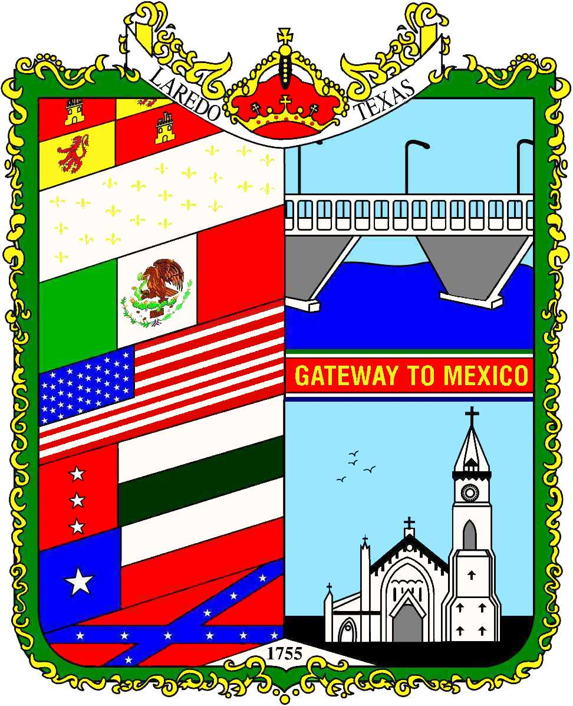

Solid Waste Services
P.O. Box 1965

Laredo, TX 78044-1965
Phones (956)-795-2510 or 956-796-1098
Fax (956)-795 -1860 or 796-1105











REGISTER
FREE ADMISSION TICKET
TO
R
EDUCE,
ECYCLE!
R
EUSE,
R
REGISTER
Recycles Day Fair 2017
Wednesday, November 15th, 2017
6912 HWY 359
Time: 10:00 a.m. to 1:30 p.m.

Reduce
Reuse
Recycle
Recycling
the
Right
Direction!

When: November 15th, 2017
Location: City of Laredo’s Solid Waste Services Picnic Area

6912 HWY 359
Time: 10:00 a.m. to 1:30 p.m.
For more information contact the Solid Waste Services at 326-1126

Laredo Recycles Day Fair 2017
Join us for an exciting event that includes:
Informational booths all related to the environment, tours of the Landfill and the Recycling Center, and an educational show you won’t want to miss.
Our theme this year is “Free Admission Ticket to Reduce, Reuse, Recycle!”
Registration Deadline: October 18th, 2017
Only one registration form per school is required. We have a limit of 550 students that can attend the fair. Lunch and a Billie Bote t-shirt will be provided only to students, teachers, and chaperones. Bus drivers are not included.
* Your registration must be confirmed by the organizers.
* Consent forms need to be turned in one week before the event. No exceptions!

Fax the form back to 956-795-1860 or by email to sgarza2@ci.laredo.tx.us

Name of School or Club:

Address:

Contact Person:

Phone: Fax: e-mail:

Total amount of children:
Total amount of Teachers:
Total amount of chaperones:

